Section I: Scenario Demographics

Scenario Title: | Anaphylaxis with Laryngospasm
Date of Development: | (23/02/2016)
Target Learning Group: | Juniors (PGY 1 – 2) Seniors (PGY ≥ 3) All Groups

Section II: Scenario Developers

Scenario Developer(s): | Donika Orlich
Affiliations/Institution(s): | McMaster University
Contact E-mail (optional): | Donika.orlich@medportal.ca

Section III: Curriculum Integration

Learning Goals & Objectives
Educational Goal: | To expose learners severe anaphylaxis and laryngospasm complication during intubation.
CRM Objectives: | - Displays leadership by maintaining calm demeanor during crisis and acting decisively  - Employs good communication skills by using closed loop, listening to the input of others, and addressing concerned family members
Medical Objectives: | - Implements the ED treatment of anaphylaxis  - Predicts and prepares for difficult intubation  - Demonstrates an approach to laryngospasm during intubation

Case Summary: Brief Summary of Case Progression and Major Events
A 7-year-old male presents with wheeze, rash and increased WOB after eating a birthday cake. He has a known allergy to peanuts. The team must initiate usual anaphylaxis treatment including salbutamol for bronchospasm. The patient will then develop worsened hypotension, requiring the start of an epinephrine infusion. After this the patient will experience increased angioedema, prompting the team to consider intubation. If no paralytic is used for intubation (or if intubation is delayed), the patient will experience laryngospasm. The team will be unable to bag-mask ventilate the patient until they ask for either deeper sedation or a paralytic. If a paralytic is used, the team will be able to successfully intubate the child.

References
Marx, J. A., Hockberger, R. S., Walls, R. M., & Adams, J. (2013). Rosen's emergency medicine: Concepts and clinical practice. St. Louis: Mosby.
Hobaika AB, Lorentz MN. [Laryngospasm]. Rev Bras Anestesiol. 2009 Jul-Aug;59(4):487-95. Review. Portuguese. PubMed PMID: 19669024
Larson CP Jr. Laryngospasm–the best treatment. Anesthesiology. 1998 Nov;89(5):1293-4. PubMed PMID: 9822036
http://lifeinthefastlane.com/ccc/laryngospasm/
Al-Metwalli RR, Mowafi HA, Ismail SA: Gentle chest compression relieves extubation laryngospasm in children. J Anesth 2010; 24:854–7. PMID: 20976504
http://first10em.com/2015/03/04/laryngospasm/

Section IV: Scenario Script

A. Scenario Cast & Realism
Patient: | Pediatric Computerized Mannequin |  |  |  |  | Realism:  Select most important dimension(s) |  |  | Conceptual
 | Mannequin |  |  |  |  |  |  |  | Physical
 | Standardized Patient |  |  |  |  |  |  |  | Emotional/Experiential
 | Hybrid |  |  |  |  |  |  |  | Other:
 | Task Trainer |  |  |  |  |  |  |  | N/A
Confederates | Brief Description of Role
Mother | To help with airway history
B. Required Monitors
EKG Leads/Wires |  |  | Temperature Probe |  |  |  | Central Venous Line
NIBP Cuff |  |  | Defibrillator Pads |  |  |  | Capnography
Pulse Oximeter |  |  | Arterial Line |  |  |  | Other:
C. Required Equipment
Gloves |  |  | Nasal Prongs |  |  |  | Scalpel
Stethoscope |  |  | Venturi Mask |  |  |  | Tube Thoracostomy Kit
Defibrillator |  |  | Non-Rebreather Mask |  |  |  | Needle cric supplies
IV Bags/Lines |  |  | Bag Valve Mask |  |  |  | Thoracotomy Kit
IV Push Medications |  |  | Laryngoscope |  |  |  | Central Line Kit
PO Tabs |  |  | Video Assisted Laryngoscope |  |  |  | Arterial Line Kit
Blood Products |  |  | ET Tubes |  |  |  | Other:
Intraosseous Set-up |  |  | LMA |  |  |  | Other: Peds NRB PEEP valve
D. Moulage
Rash over arms and legs.

E. Approximate Timing
Set-Up: |  | 3 min |  | Scenario: | 15 min |  |  | Debriefing: |  | 30 min

Section V: Patient Data and Baseline State

A. Clinical Vignette: To Read Aloud at Beginning of Case
A 7-year-old boy arrives via EMS with increased work of breathing. He has a known allergy to peanuts and developed symptoms after eating birthday cake at a party. He has been given 0.15mg IM epinephrine 10 minutes ago by his mother. Current vital are: HR 140, BP 85/60, RR 40, O2 98% on NRB. He has some ongoing wheeze noted by EMS.
B. Patient Profile and History
Patient Name: Cayden McFadden |  |  |  |  |  | Age: 7 |  |  |  |  |  |  |  | Weight: 28 kg
Gender: M F |  |  |  |  |  | Code Status: Full.
Chief Complaint: Allergic Reaction
History of Presenting Illness: Ate cake at a party and developed wheeze, shortness of breath and rash within 10 minutes. Mother administered his epinephrine auto-injector and called EMS.
Past Medical History: |  | Allergy to peanuts |  |  |  |  | Medications: |  |  |  |  | Epinephrine auto-injector
Allergies: Peanuts.
Social History: Lives with parents.
Family History: Non-contributory.
Review of Systems: |  | CNS: |  |  | Nil
 |  | HEENT: |  |  | No facial/mouth swelling.
 |  | CVS: |  |  | Nil.
 |  | RESP: |  |  | Audible wheeze.
 |  | GI: |  |  | Complaining of stomach pains. No vomiting.
 |  | GU: |  |  | Nil.
 |  | MSK: |  |  | Mil |  |  |  |  |  |  |  | INT: |  | Rash over entire body.
C. Baseline Simulator State and Physical Exam
No Monitor Display |  |  |  | Monitor On, no data displayed |  |  |  |  |  |  | Monitor on Standard Display
HR: 130/min |  |  | BP: 80/50 |  |  |  |  | RR: 40/min |  |  |  |  |  |  | O₂SAT: 97% NRB
Rhythm: Sinus |  |  | T: 36.1ºC |  |  |  |  | Glucose: 6.2 mmol/L |  |  |  |  |  |  | GCS: 15 (E4 V5 M6)
General Status: Unwell
CNS: | Alert, oriented. Appears scared.
HEENT: | No facial/airway edema.
CVS: | Normal HS. No murmur.
RESP: | Audible wheeze. Chest tight. Tracheal tug. Intercostal indrawing.
ABDO: | Soft, diffuse discomfort. No rebound. No peritonitis
GU: | Nil.
MSK: | Nil |  |  |  |  |  |  |  | SKIN: | Rash over entire body.

Section VI: Scenario Progression

Scenario States, Modifiers and Triggers
Patient State | Patient Status | Learner Actions, Modifiers & Triggers to Move to Next State
1. Baseline State  Rhythm: NSR  HR: 120/min  BP: 80/50  RR:40/min  O₂SAT: 97% NRB  T: 36.1ºC | Significant work of breathing.  Mother panicked at bedside. | Learner Actions  - Monitors, O2, IV access  - IM epinephrine left lateral thigh at 0.01mg/kg  - IV Benadryl (1mg/kg)  - IV Ranitidine (1mg/kg)  - IV Methylprednisolone (1-2mg/kg)  - IV NS bolus (20mL/kg)  - Salbutamol (5mg) and Ipatropium (0.5mg) in 3mL NS neb  - Cap glucose  - Portable CXR | Modifiers  Changes to patient condition based on learner action  - Epi HR 130, BP 85/50  - NS bolus HR 125, BP 85/55  - Ventolin/Atrovent O2 99%, increase air entry  - Mother not consoled increasing agitation and becomes obstructive  Triggers  For progression to next state  - Epi, antihistamines, steroids given 2. Hypotension  - 5 minutes 2. Hypotension
2. Hypotension  HR: 140  BP: 60/40  RR: 42  O₂SAT: 97% NRB | Patient states he feels dizzy | Learner Actions  - IV NS bolus (20mL/kg)  - Repeat IM epinephrine at 0.01mg/kg/dose  - Start iv epinephrine infusion at 0.1mcg/kg/min | Modifiers  - NS bolus BP 70/50  - Epi infusion BP 85/60  - No Epi infusion by 5 minutes nurse suggests it  Triggers  - Epi infusion started  3. Airway Obstruction
3. Airway Obstruction  O₂SAT 89% over 60 sec.  HR: 150  RR: 48  BP: 88/60 | Patient complains of throat tightness and tongue swelling | Learner Actions  - Nebulized epinephrine  - Prepare for intubation  - Call Anesthesia/ENT  - Call for difficult airway cart +/- transtracheal jet set-up  - Multiple ETT sizes available  - Consent from mother  - IV Fluid bolus (20mL/kg)  - Push-dose Epi at bedside (give 1mcg/kg bolus q2-3 min) OR increase infusion rate peri-intubation | Modifiers  - Epi neb O2 94% NRB, RR 40  - IV fluid BP 90/65, HR 130  Triggers  - Intubation attempt without paralytic 4. Laryngospasm  - Intubation with paralytic  6. Resolution  - No intubation 4 min into state 4. Laryngospasm
4. Laryngospasm  HR to 110 over 1 min  O₂SAT 65% over 60 sec.  RR 0  BP 80 /60 | High pitched stridor noise, followed by no visible chest movement. | Learner Actions  - BVM ventilation with PEEP valve (difficult to bag with poor chest rise)  - Update team  - Apply pressure to Larson’s point with jaw thrust  - Administer deeper sedation  - Administer paralytic  - Intubate after paralytic | Modifiers  - 1 min of BVM O₂SAT to 75%  Triggers  - Paralytic given  6. Resolution  - 2 min of laryngospasm  5. Bradycardia
5. Bradycardia  O₂SAT 95% over 1 min of bagging  HR 35 over 1 min |  | Learner Actions  - Give atropine 0.02mg/kg iv (0.56mg)  - Continue bagging patient if not yet intubated | Modifiers  Triggers  - Atropine given  6. Resolution  - 13 minutes 6. Resolution
6. Resolution  HR: 100/min  BP: 90/50  RR: 10 (vented)  O₂SAT: 100% |  | Learner Actions  - Post-intubation sedation  - ICU Consult  - Update mother | Modifier  - Mother not updated gets very upset. Questions care. Threatens to sue.  Triggers  - ICU consult END CASE

Section VII: Supporting Documents, Laboratory Results, & Multimedia

Laboratory Results
No blood work required.

Images (ECGs, CXRs, etc.)
Initial CXR - normal pediatric CXR  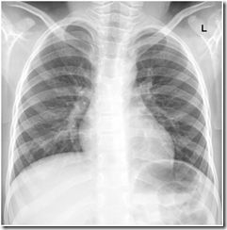  CXR source: http://radiology-information.blogspot.ca/2015/04/normal-chest-x-ray.html | Post-intubation - normal  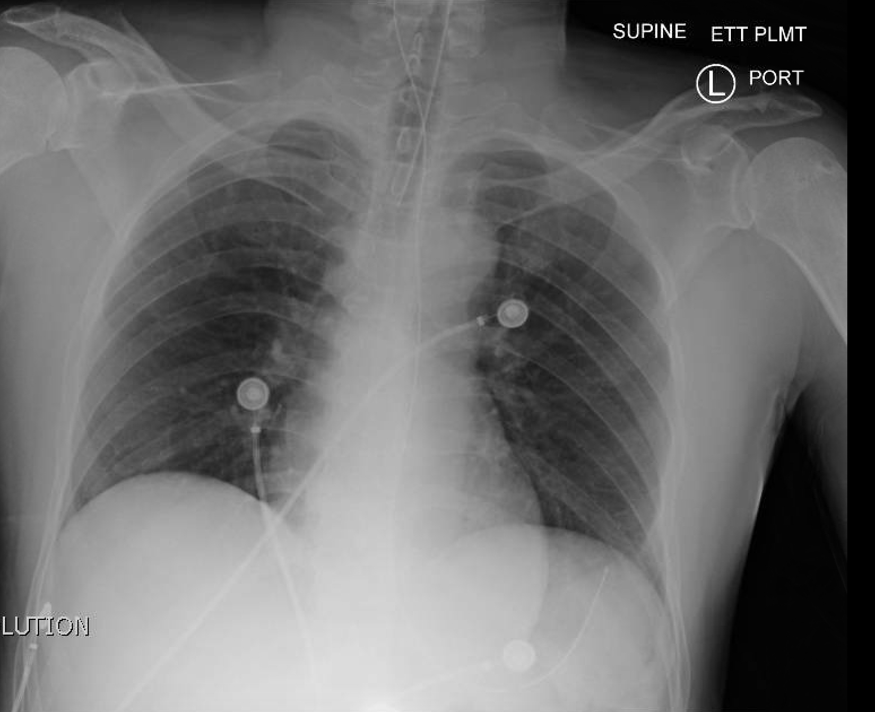  CXR source: http://jetem.org/ettcxr/

Section VIII: Debriefing Guide

General Debriefing Plan
Individual | Group |  | With Video | Without Video
Objectives
Educational Goal: |  | To expose learners severe anaphylaxis and laryngospasm complication during intubation.
CRM Objectives: |  | - Displays leadership by maintaining calm demeanor during crisis and acting decisively  - Employs good communication skills by using closed loop, listening to the input of others, and addressing concerned family members
Medical Objectives: |  | - Implements the ED treatment of anaphylaxis  - Predicts and prepares for difficult intubation  - Demonstrates an approach to laryngospasm during intubation
Sample Questions for Debriefing
- When did you decide to switch over to IV Epinephrine? What are its indications?
- What was your approach to pending airway obstruction? What was your back-up method of securing the airway?
- What is your approach to laryngospasm?
- What is Larson’s point?
- What are some other complications of sedation with ketamine?
- How did it feel as a team to manage this extremely unexpected complication? Do you feel you remained calm?
- How did the leader address the critical nature of this complication? As a team, did you feel that you had clear directions?
Key Moments
Recognition and treatment of anaphylaxis and it’s complications including bronchospasm, hypotension and airway obstruction
Recognition of Laryngospasm
Recognition of hypoxia-mediated bradycardia

